

Internship Report

A report submitted in partial fulfillment of
Integrated BTech in Computer Engineering(AI & DS)

Prepared by
Harsh Gidwani

Under the Guidance of
Prof. Jyoti Khurpade
Mr. Sanjay Mangalaram
[Stark Digital Media Services Pvt Ltd.]

Integrated BTech in Computer Engineering
At
Department of
Polytechnic & Skill Development

Date of Submission
[ 08th Aug 25 ]

Annexure 3

TITLE PAGE OF INTERNSHIP REPORT



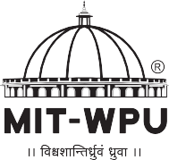

AI Internship

An Internship Report Submitted to:
DR. VISHWANATH KARAD
MIT WORLD PEACE UNIVERSITY

Submitted by,

Harsh Gidwani (1032230503)

Under the supervision of
Mr. Sanjay Mangalaram
And
Prof. Jyoti Khurpade
Department of Polytechnic and Skill Development ______________________________

Dr VK MIT World Peace University, Kothrud, Pune-411038
(Period from June -2025 to August 2025)

ANNEXURE – 3

CERTIFICATE OF INTERNSHIP



CERTIFICATE
This is to certify that the Internship Report entitled

AI Internship

Submitted by:

Harsh Gidwani (1032230503)

In partial fulfilment of requirement of an Internship at Stark Digital Media Services Pvt. Ltd., is a bonafide record of the work carried out by him during the period from June to Aug. He has worked under the supervision of Sanjay Mangalaram and Prof. Jyoti Khurpade. He has fulfilled the requirement of the submission of the Internship report for Third Year Computer Science(AI & DS) Engineering as per the syllabus prescribed by the MIT World Peace University, Pune.

Name | Name | Name
Company Supervisor | College Mentor | Program Head

Vision
To be an acclaimed school which facilitates to earn enriching knowledge, skills and lifelong learning in the streams of engineering to promote “culture of world peace.”

Mission
“To facilitate our students and the faculty with exposure and platform to contemporary practices to meet various challenges in ever advancing sectors of their field while using the gained knowledge for the welfare of human being.”
“To imbibe personal attributes and facilitate the students to pursue higher education and / or venture into entrepreneurship avenues by building competence to comprehend society/social needs.”

Certificate of Completion

This is to certify that Mr. __Harsh Gidwani __ with PRN number __1032230503_ of class SYCO has successfully completed internship work during the period of _June-25_ to _August 2025_. The report is being submitted towards partial fulfillment of Integrated BTech program in Computer Engineering for academic year 2024-25.

Internship Mentor Program Head Program Director
(Sanjay Mangalaram) ( Prof.J.G.Mante) (Prof.Dr.R. S. Kale)

Date – 08/Aug/2025
Place – Pune

Acknowledgements

I would like to thank Mr. _Amit Mohol_ the Director of Stark Digital Media Services Pvt. Ltd. for giving me the opportunity to do an internship within the organization.
I am also grateful to Program Director Prof. Dr. R. S. Kale and Program Head Prof. J. G. Mante for facilitating and supporting this internship program.
I am thankful to (Institute Mentor) Prof. Jyoti Khurpade_ for her continuous support & guidance during the internship period. I am thankful to (Industry /Mentor) _Mr Sanjay Mangalaram _ for his timely help & guidance during the internship period
I am also thankful to all those from Stark Digital Media Services Pvt. Ltd for making my working environment happy and rich.

Harsh Gidwani

Table of Contents

Ch. no | Topic Name | Page no
1 | Company Profile / Introduction of Company | 8
 | Products, processes, customers, awards, infrastructure, organization chart
2 | Department worked in / Jobs performed on | 11
 | Department 1 / Job 1 / Activity 1
 | Department 2 / Job 2 / Activity 2 if applicable
 | (Write what you learn day wise (Or in appropriate order) in these spaces. If you have prepared daily diary-Annexure-1, same contents to be written in well-organized manner.)
3 | Analysis / Result  Here comes output of the work done during internship in terms of  Result/screen shot/document/file/table / or any other relevant | 15
4 | Observations & Challenges experienced during internship | 19
5 | Conclusions (Write appropriate conclusion of ½ page based on your learning. You may add course wise conclusions.) | 22

(After this attach certificates of course completion / certificate from industry if any)

Company Profile / Introduction
- About Stark Digital Media Services Pvt. Ltd.
- Company Vision and Mission
- Products and Services
- Key Achievements
- Infrastructure and Technology Stack
- Organization Structure

Chapter 1: Company Profile / Introduction
1.1 About Stark Digital Media Services Pvt. Ltd.
Stark Digital Media Services is a leading technology company specializing in digital transformation solutions, with over 14 years of industry expertise. The company has a presence in 15+ countries and serves over 25 industry sectors, ranging from startups to government organizations.
1.2 Company Vision and Mission
- Vision: To be a global leader in digital transformation, delivering innovative technology solutions that drive business growth and societal impact.
- Mission: To empower organizations with cutting-edge digital solutions through expert talent, innovative technologies, and end-to-end development services.
1.3 Products and Services
- Web Development: Full-stack web applications and e-commerce solutions
- Mobile App Development: Native and cross-platform mobile applications
- Artificial Intelligence: AI-powered chatbots, automation systems, and machine learning solutions
- Digital Marketing: Comprehensive digital marketing and brand management services
- Enterprise Solutions: Custom software development for enterprise clients
- Government Solutions: Digital transformation for public sector organizations
1.4 Key Achievements
- 600+ Projects Delivered: Successfully completed within specified timeframes
- 50+ Global Brands: Managed digital solutions for more than 50 international brands
- 75+ Technical Team: In-house team skilled in 20+ cutting-edge technologies
- Multi-industry Expertise: Serving healthcare, e-commerce, government, finance, and more
1.5 Infrastructure and Technology Stack
- Frontend: React.js, Next.js, Angular, Vue.js
- Backend: Node.js, Python, PHP, Java
- AI/ML: TensorFlow, PyTorch, OpenAI, LangChain
- Cloud: AWS, Google Cloud, Microsoft Azure
- Databases: MongoDB, PostgreSQL, MySQL, Redis
1.6 Organization Structure
- Executive Leadership: CEO, CTO, Senior Management
- Development Teams: Specialized per technology domain
- AI Department: Dedicated artificial intelligence & machine learning division
- Quality Assurance: Comprehensive testing & QC
- Project Management: Agile project management & client coordination

Department Worked In / Jobs Performed
- AI Development Department
- Job 1: E-commerce Chatbot Development - WooCommerce GST Chatbot
- Job 2: Enterprise AI Systems - Enterprise RAG ChatBot
- Job 3: Government Service Automation - PMC Website Chatbot
- Job 4: Healthcare Technology - AI Voice Agent for Hospital
- Job 5: Document Processing Systems - DocLens

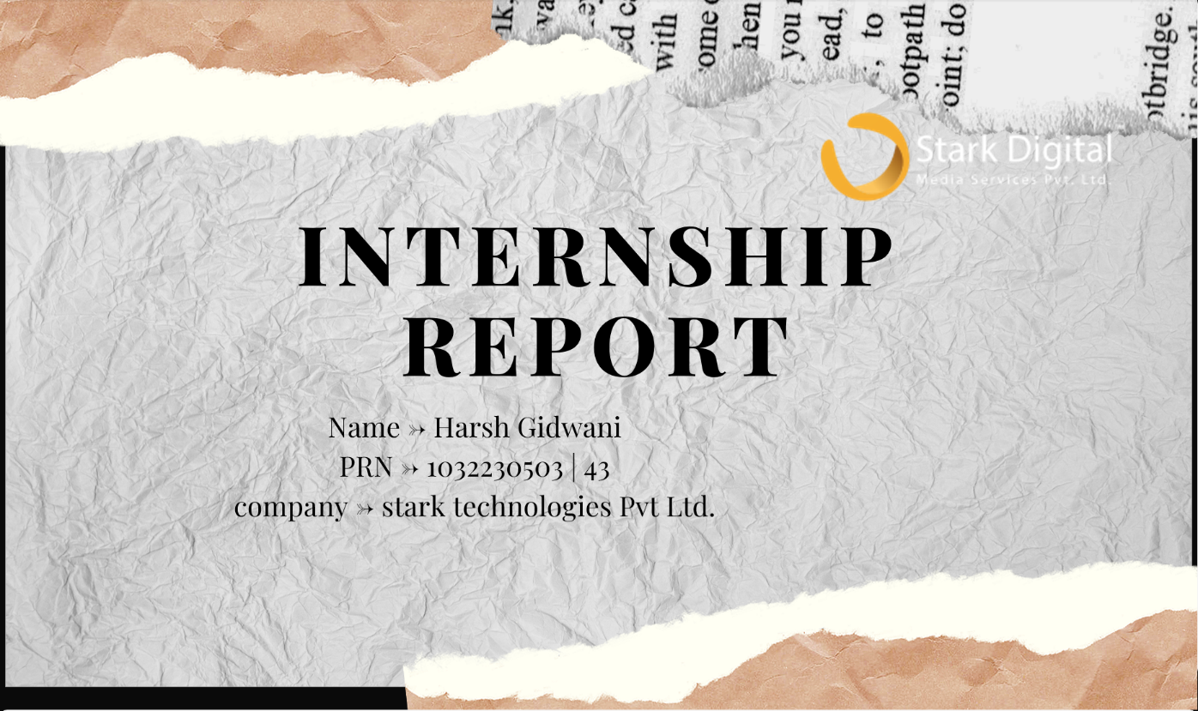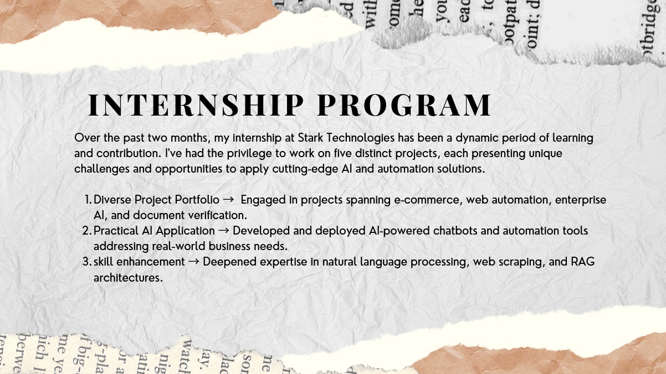

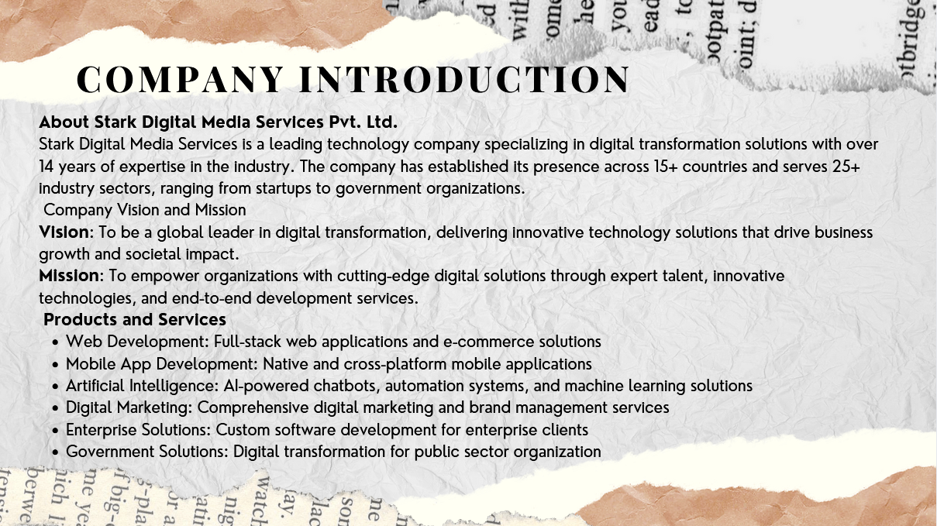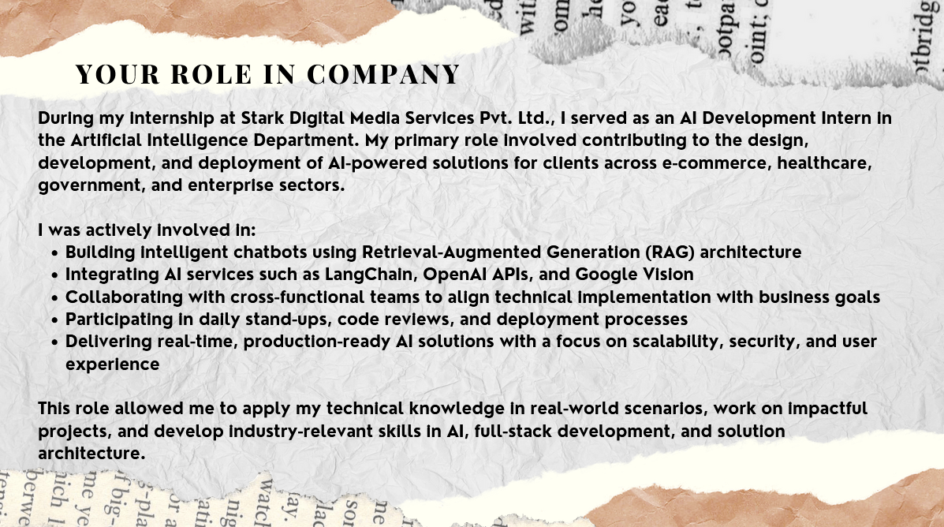

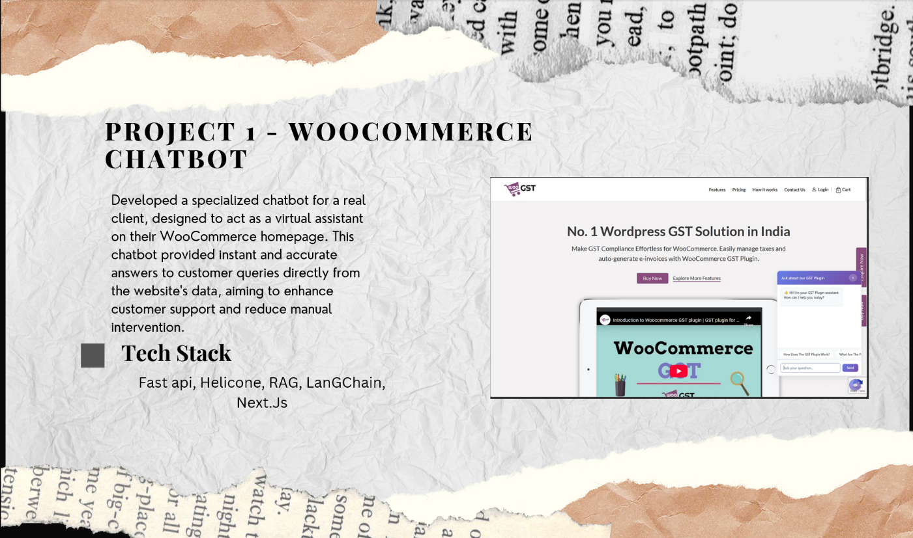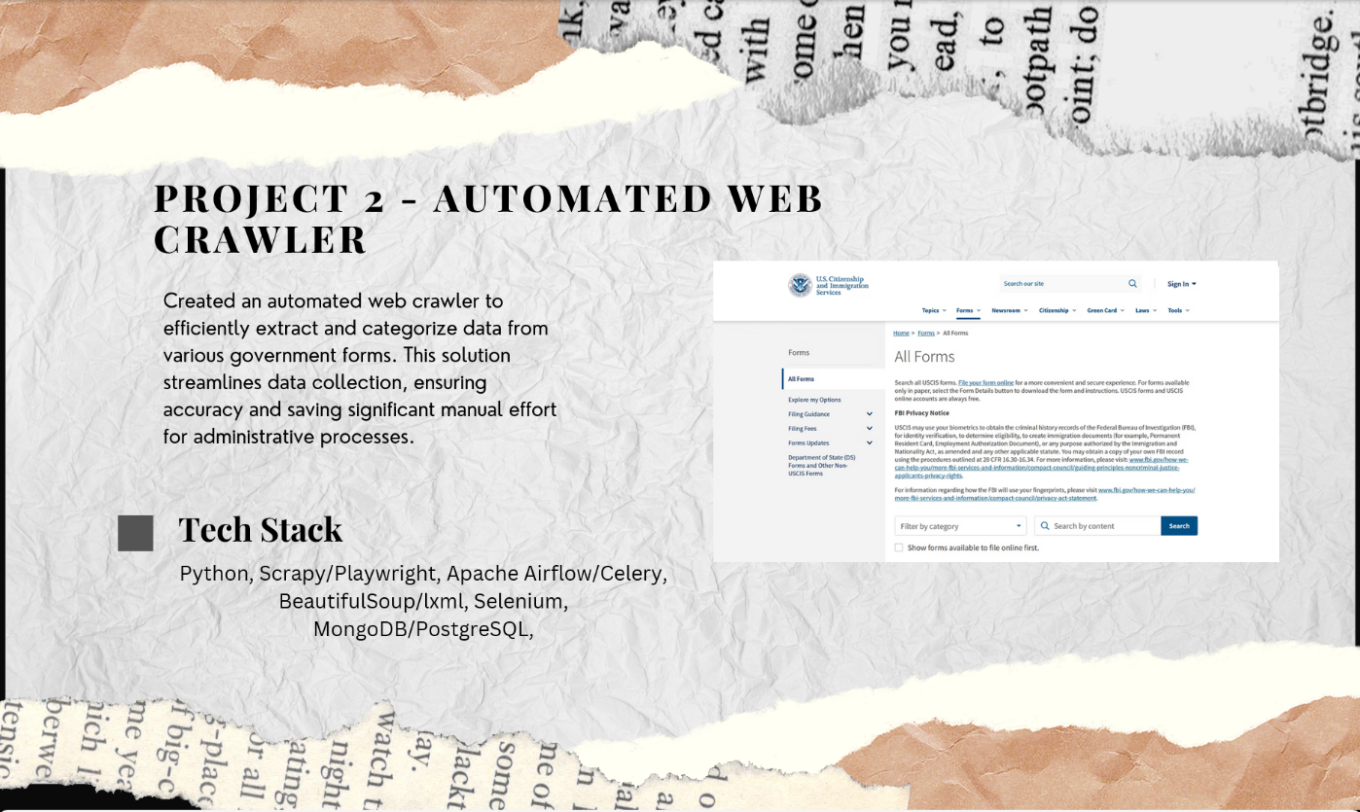

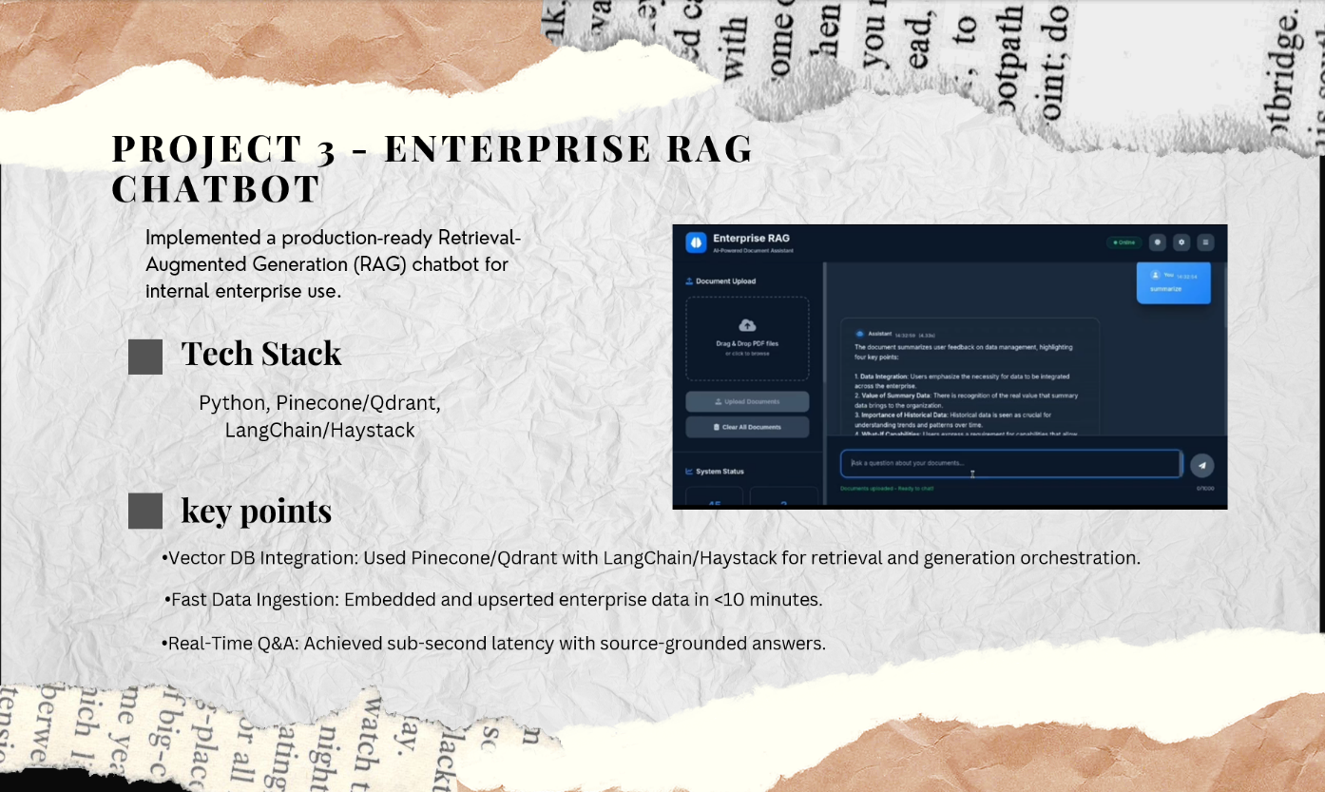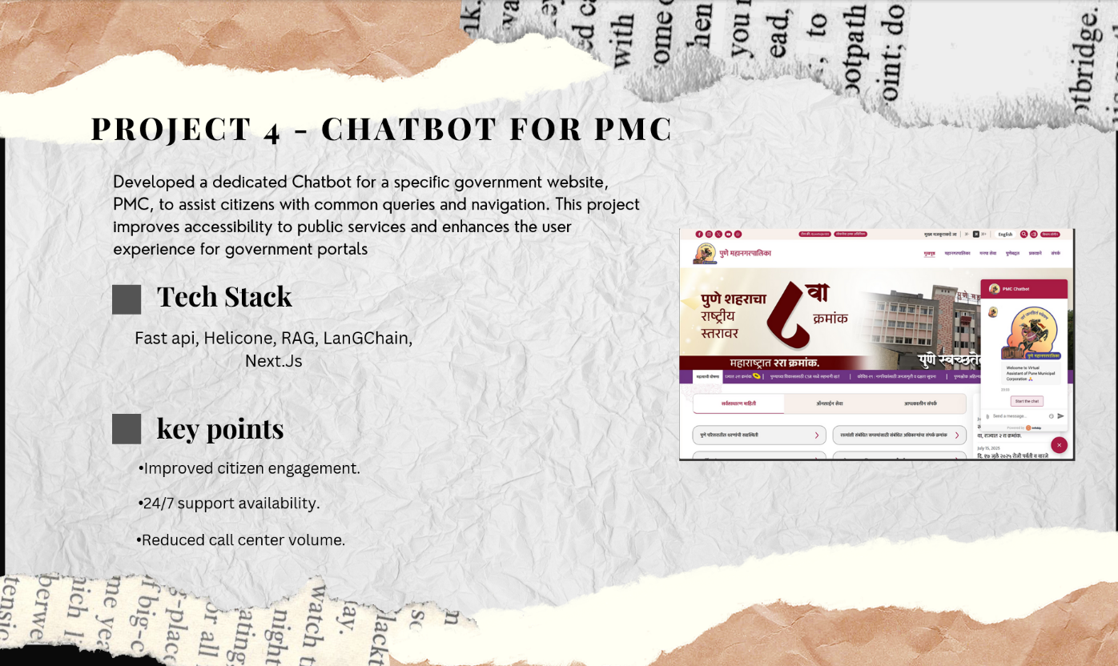

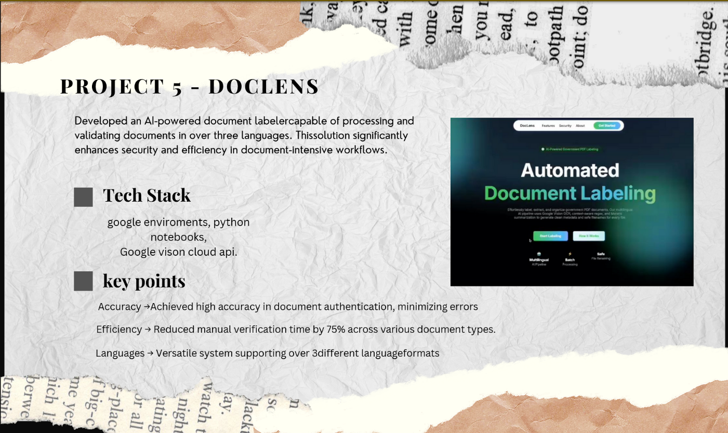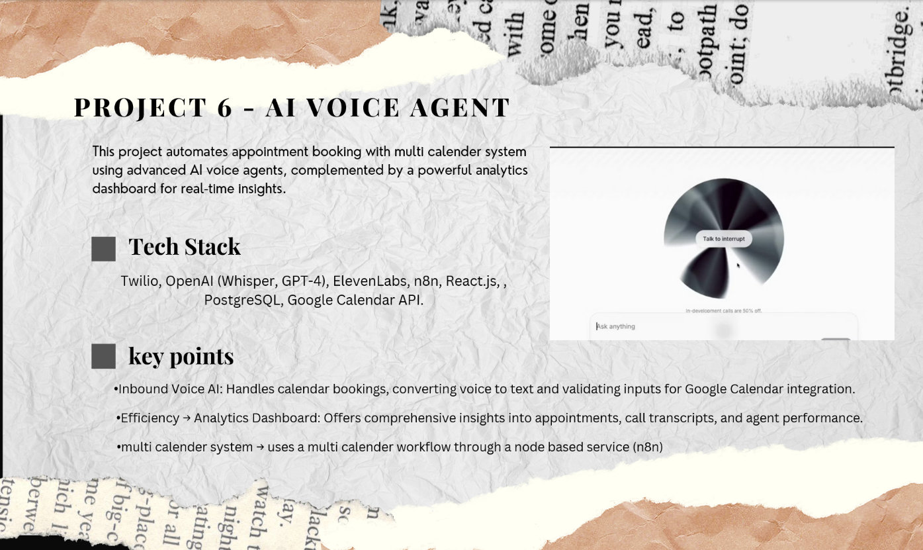

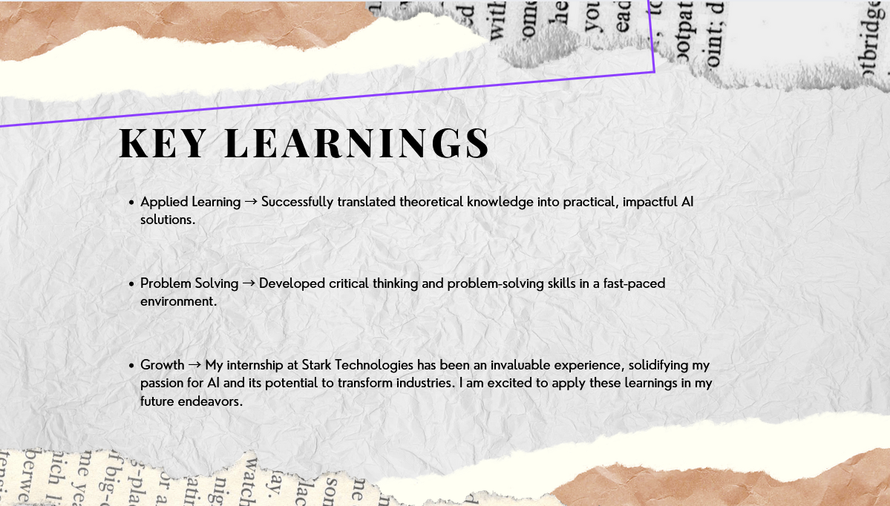
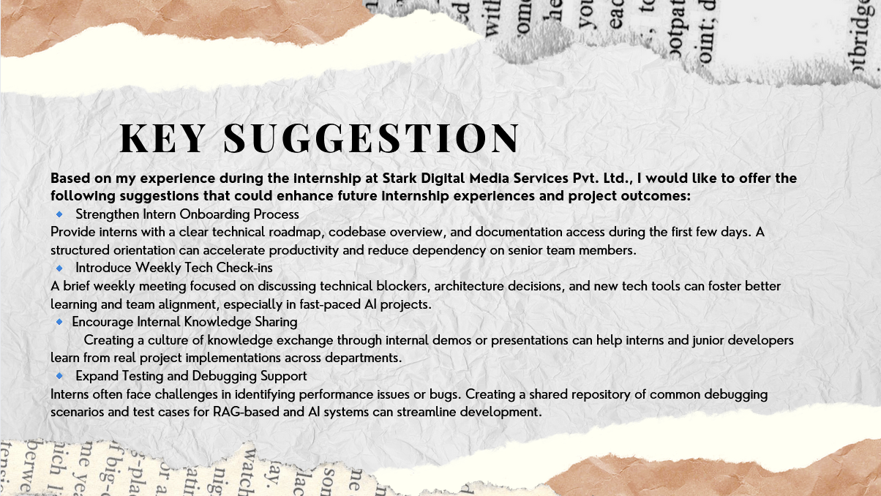
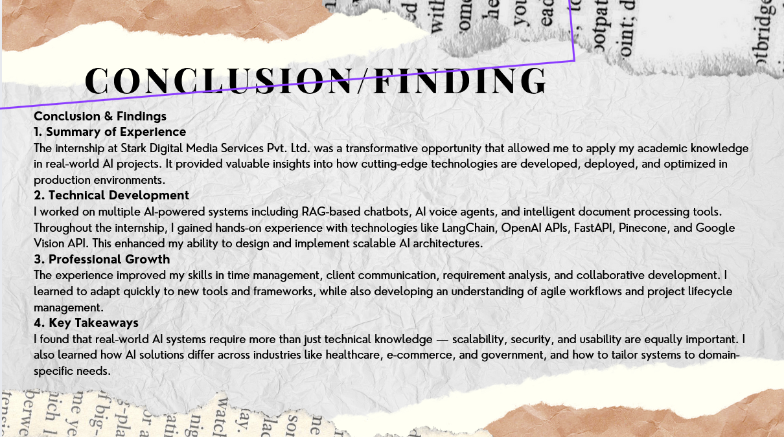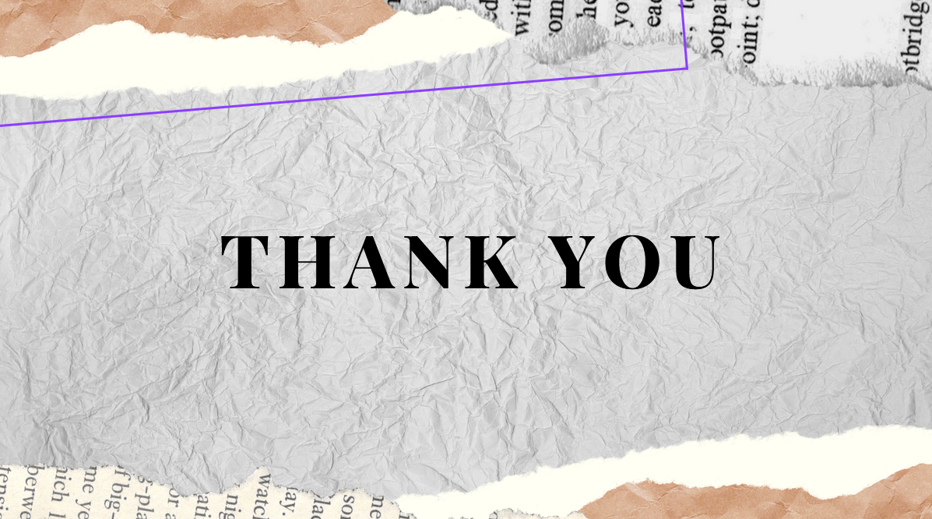

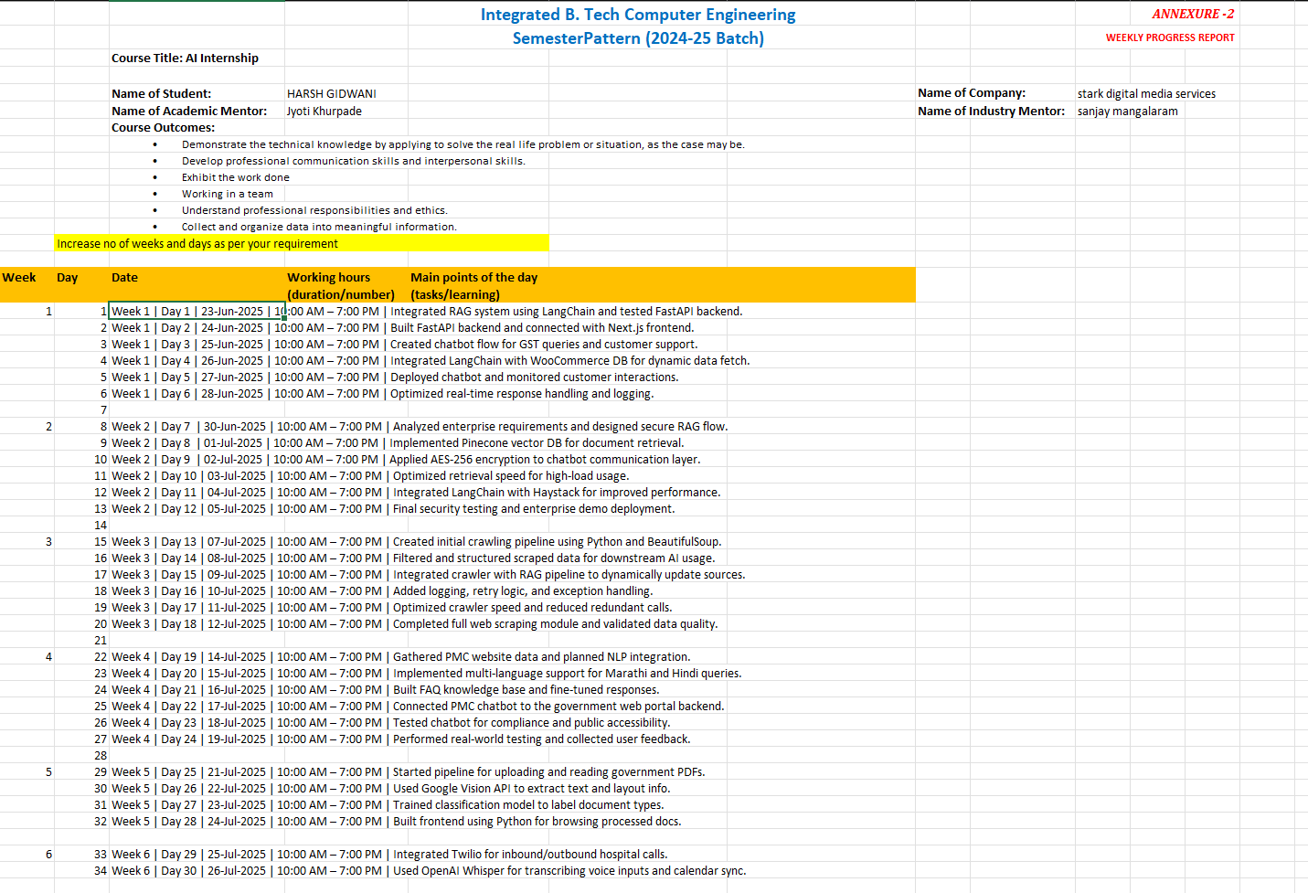

DEMO SCREENSHOTS OF WORK AND PROJECTS.

PMC CHATBOT -> ENTERPRISE RAG CHATBOT ->

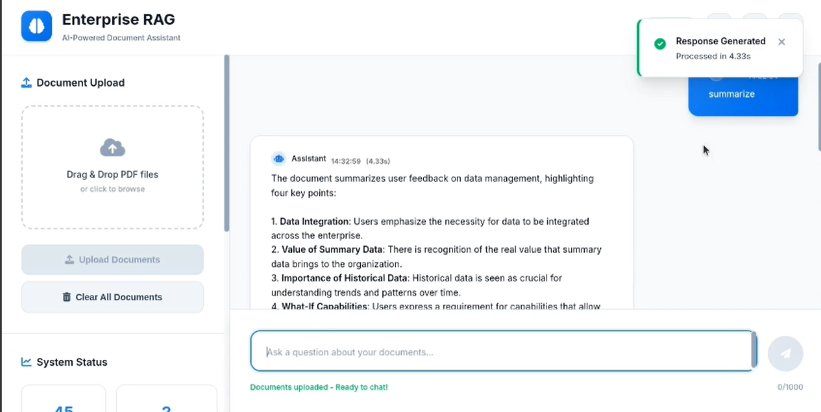

DOCUMENT VERIFICATION SYSTEM ->

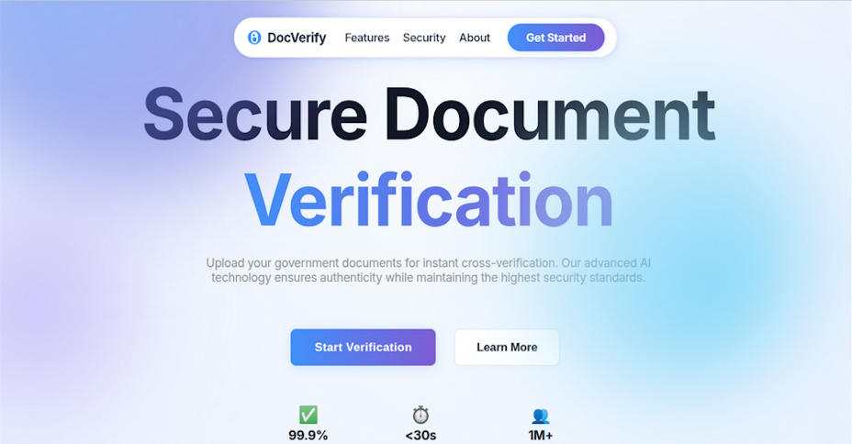
GOVERNMENT FORM LABELER ->
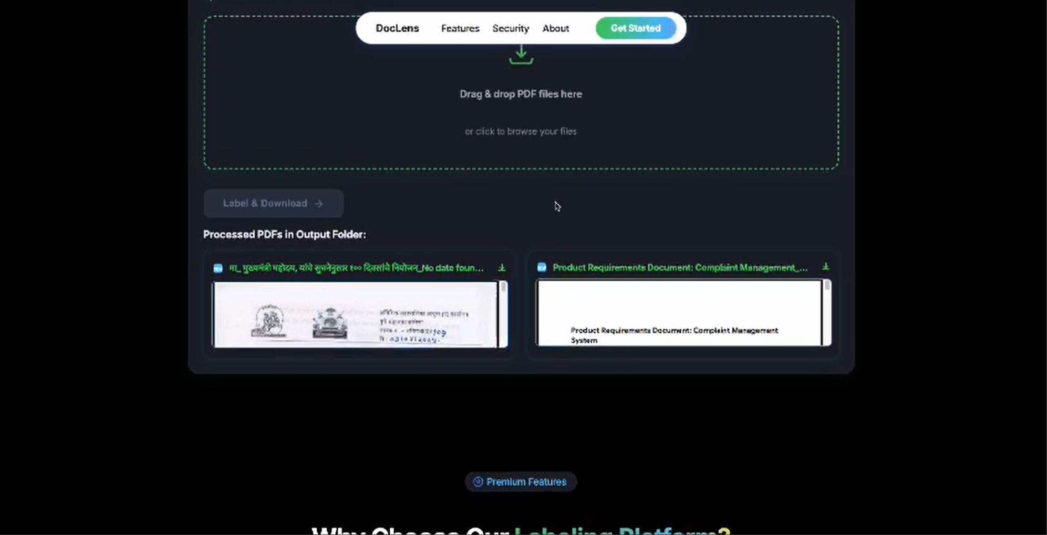

AI VOICE AGENT ->

WOOCOMMERCE CHATBOT ->

Chapter 2: Department Worked In / Jobs Performed
2.1 AI Development Department
I was assigned to the AI Development Department, focused on intelligent automation, chatbots, and machine learning solutions.
Structure:
- AI Team Lead
- ML Engineers
- NLP Engineers
- Full-stack Developers
- Interns
2.2 Job 1: E-commerce Chatbot Development - WooCommerce GST Chatbot
Duration: Week 1-3
Objective: Develop a virtual assistant for instant customer support on a WooCommerce website.
Daily Activities:
- Requirement analysis & system design
- FastAPI backend & database setup
- RAG system with LangChain
- Frontend using Next.js & API integration
- Testing, deployment, performance optimization
Technologies: FastAPI, LangChain, Helicone, Next.js, RAG architecture
Learning Outcomes:
- Production chatbot development
- Real-time data integration
- Customer support automation
- Client interaction skills
2.3 Job 2: Enterprise AI Systems - Enterprise RAG ChatBot
Duration: Week 4-5
Objective: Implement a production-ready RAG chatbot for enterprise use.
Daily Activities:
- Requirements analysis, security
- Vector database (Pinecone/Qdrant) setup
- LangChain document retrieval/generation
- AES-256 encryption implementation
- Performance optimization
Technologies: Python, Pinecone/Qdrant, LangChain/Haystack, AES-256 encryption
Learning Outcomes:
- Enterprise security
- Scalable architecture
- Vector database optimization
- Production deployment
2.4 Job 3: Government Service Automation - PMC Website Chatbot
Duration: Week 6
Objective: Dedicated chatbot for Pune Municipal Corporation website.
Daily Activities:
- Requirement analysis
- PMC service knowledge base creation
- Multi-language support
- Integration with government systems
Learning Outcomes:
- Public service automation
- Government compliance
- Multi-language NLP
- Citizen engagement strategies
2.5 Job 4: Healthcare Technology - AI Voice Agent for Hospital
Duration: Week 7
Objective: AI voice agent for hospital appointment booking, multi-doctor scheduling.
Daily Activities:
- Healthcare workflow analysis, HIPAA
- Twilio integration for voice
- OpenAI Whisper for speech recognition
- Google Calendar API for scheduling
- ElevenLabs voice synthesis
Technologies: Twilio, OpenAI (Whisper, GPT-4), ElevenLabs, Google Calendar API, Python
Learning Outcomes:
- Healthcare technology development
- Voice AI implementation
- Real-time scheduling
- Medical compliance
2.6 Job 5: Document Processing Systems - DocLens
Duration: Week 8
Objective: Intelligent system for labeling and categorizing government PDF documents.
Daily Activities:
- Document analysis, Google Vision API setup
- PDF processing pipeline
- Machine learning classification model training
- Python frontend for document management
Technologies: Google Vision API, FastAPI, Python, custom ML models
Learning Outcomes:
- Computer vision development
- Document processing automation
- Data management
- Classification algorithm implementation

Analysis / Result
  - Project Outcomes and Deliverables
  - Technical Skills Developed

Chapter 3: Analysis / Result
3.1 Project Outcomes and Deliverables
3.1.1 WooCommerce GST Chatbot
- Status: Live Production
- URL: https://woocommercegst.co.in/
- Performance: Real-time response, 24/7 support, reduced manual intervention, enhanced satisfaction
3.1.2 Enterprise RAG ChatBot
- Status: Production Ready
- Performance:
  - Data ingestion <10 mins
  - Sub-second latency
  - AES-256 encryption
  - Scalability for concurrent users
3.1.3 Government Website Chatbot (PMC)
- Status: Completed
- Impact: 24/7 citizen service, reduced call center, improved accessibility
3.1.4 AI Voice Agent for Hospital
- Status: Fully Functional
- Features: Multi-doctor scheduling, natural conversations, Google Calendar integration, ElevenLabs synthesis
3.1.5 DocLens Document Processing
- Status: Operational
- Capabilities: Automated analysis, intelligent categorization, high-accuracy extraction, scalable processing
3.2 Technical Skills Developed
- Programming Languages: Python, JavaScript, SQL
- AI/ML: LangChain, OpenAI APIs, Google Vision, Vector DBs
- Web Development: FastAPI, Next.js, React.js, DB integration
- Business Impact: Delivered production systems, enterprise solutions, public service automation

Observations & Challenges Experienced
  - Technical Challenges
  - Professional Development Challenges
  - Industry Insights

Chapter 4: Observations & Challenges Experienced
4.1 Technical Challenges
4.1.1 Real-time Data Integration
- Challenge: Dynamic content extraction for chatbot
- Approach: Caching, incremental data updates
- Learning: Production synchronization, optimization
4.1.2 Enterprise Security Implementation
- Challenge: AES-256 encryption with performance
- Approach: Industry best practices, protocol optimization
- Learning: Security & compliance
4.1.3 Multi-platform Integration
- Challenge: Diverse API integration
- Approach: Standardized API wrappers, error handling
- Learning: Microservices, API integration
4.1.4 Computer Vision Accuracy
- Challenge: High classification accuracy
- Approach: Preprocessing pipelines, confidence scoring
- Learning: Computer vision accuracy
4.2 Professional Development Challenges
4.2.1 Client Communication
- Improved communication and requirement gathering skills
4.2.2 Project Timeline Management
- Applied agile, prioritized tasks, improved time allocation
4.2.3 Technology Adaptation
- Rapid learning, applied systematic approaches, mentorship
4.3 Industry Insights
- AI requires business context understanding
- Production systems need monitoring, security, performance
- Cross-functional collaboration is critical
- Clear communication bridges tech and business

Conclusions
  - Overall Learning Experience
  - Technical Competency Development
  - Professional Growth
  - Course-wise Integration
  - Future Directions
  - Final Reflection

Chapter 5: Conclusions
5.1 Overall Learning Experience
Two months at Stark Digital Media Services gave comprehensive exposure to real-world AI challenges, bridging academic learning with industry application.
5.2 Technical Competency Development
AI/ML Expertise
- Practical implementation from design to deployment (LangChain, OpenAI, vector DBs)
Full-Stack Development
- Backend APIs to frontend UI (FastAPI, Next.js, DBs)
Production Systems
- Deployment, monitoring, user experience
5.3 Professional Growth
Problem-Solving
- Creative solutions for technical and workflow challenges
Industry Awareness
- Exposure to AI in e-commerce, healthcare, government, enterprise
Collaboration/Communication
- Enhanced teamwork and professional communication
5.4 Course-wise Integration
- Computer Programming: Production code, optimization, debugging
- Database Management: Real project DB integration, optimization
- Software Engineering: Full SDLC experience
- Artificial Intelligence: Practical ML, NLP, computer vision
5.5 Future Directions
Clear direction in AI/software engineering, focusing on emerging technology skill development.
5.6 Final Reflection
The internship exceeded expectations: challenging projects, valuable mentorship, and real-world exposure fostered significant professional and personal growth, reinforcing the importance of continual learning in AI and its real-world impact. 